Build a Serverless Web Application

Today we are going to build a fully serverless application which will include the following services:
- Amazon SQS
- AWS Lambda
- Amazon DynamoDB
- Amazon S3
- Amazon API Gateway
The application uses a static website hosted in Amazon S3 that connects to an Amazon API Gateway. The website allows shop owners to manually submit product purchase information to the DynamoDB Table.
When data is entered into the webform running on S3, the API triggers and AWS Lambda function to place the data as a message in an SQS queue.
Another Lambda function is then triggered and processes the message in the queue and adds the data to the DynamoDB table.
The image below depicts the solution architecture:
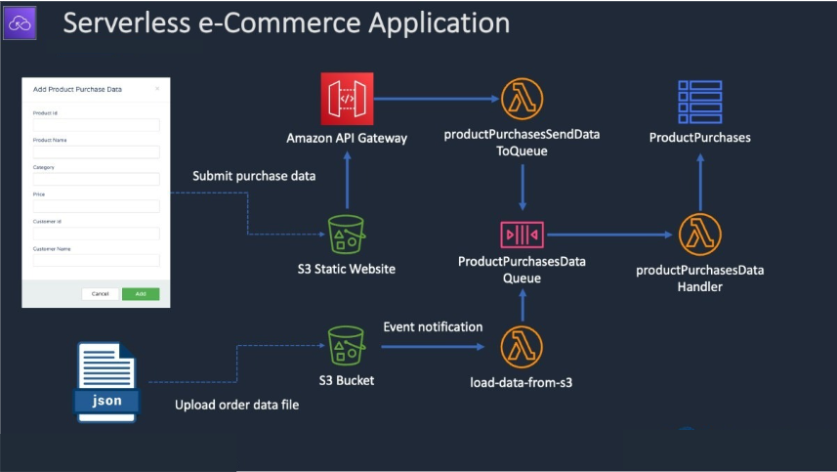

Requirements (Prerequisites)

  - AWS Free Tier Account
  - The AWS CLI or AWS CloudShell
Resources
See folder called “build-a-serverless-app” on GitHub repo
Exercise Overview
Exercise 1 - Create the DynamoDB Table
Exercise 2 - Create the SQS Queue
Exercise 3 - Create the first Lambda Function
Exercise 4 - Send message via the CLI to test the SQS Queue
Exercise 5 - Create the second Lambda Function
Exercise 6 - Create the API
Exercise 7 - Create the Static Website, and Test the application

Exercise 1 - Create the DynamoDB Table
Task 1 – Create the DynamoDB Table

First we will create the DynamoDB table which will store the transactions made from the front end.
- Head over to the DynamoDB console and click on Create Table.
- Call the table ‘ProductPurchases’ and enter ‘ProductPurchaseKey’ for the partition key.

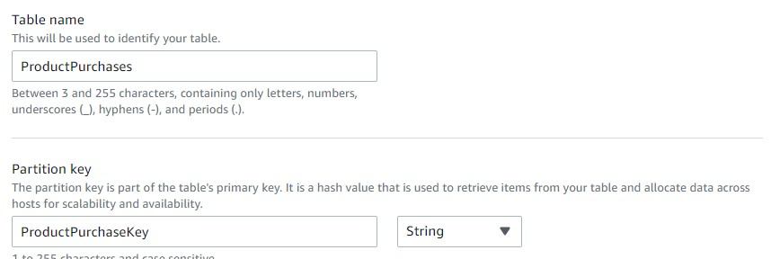

- Scroll down and click ‘Create Table.’

Exercise 2 - Create the SQS Queue
Task 1 – Create the SQS Queue

First we will create the SQS Queue which will store the messages from the front end.
- Head over to the SQS console, and click on Create Queue
- Leave the queue as a Standard Queue and call it
‘ProductPurchasesDataQueue’.
- We don’t need to make any more changes other than scrolling down and clicking ‘Create Queue’.
- Take note of the URL which you can see on the next screen by saving it in a notepad document.

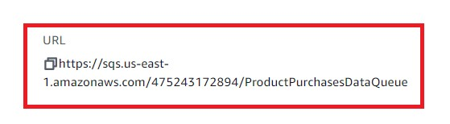
Exercise 3 - Create the first Lambda Function
Task 1 – Create the IAM Role

Next, we will create the Lambda execution role.
- Head over to the IAM console and click on Create policy.
- Under the JSON tab find and copy contents of ‘lambda-policy-for-sqsddb.json’ into the JSON field, ensuring you replace your account number.
- Click ‘Create Policy’ after calling the permissions policy "pushPurchasesToQueue".
- We then need to attach this policy to a role. Select Roles in the IAM console and click ‘Create Role’.
- Under ‘Use Case’ select Lambda and click next.
- Filter the permissions policy by typing in the name of the policy we just created (‘pushPurchasesToQueue’) attach it and click next.
- We will then call the role ‘pushPurchasesToQueue’ and click ‘Create Role.
Task 2 – Create the first Lambda Function

Next, we will create the first Lambda function which processes messages from the queue and places the order entries into the DynamoDB table.
- Head over to the Lambda console and click on Create Function.
- We will call the Lambda function ‘productPurchasesDataHandler’ and change the runtime to ‘Node.js 16.x’.
- Click on ‘Change Default Execution Role and click ‘Use and Existing Role’ and use the ‘pushPurchasesToQueue’ we selected earlier.
- Click ‘Create Function’.
- Now we can add the code. Under ‘Code’ choose ‘Upload from’ and select the zip file.

- Upload zip file (DCTProductPurchasesTracking.zip) from the resource download (build-a-serverless-app > Part-1) and click on save.

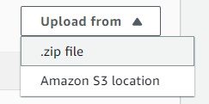

Task 3 – Configure the SQS Queue

First we will configure the SQS Queue which triggers the Lambda function we just created.
- Head back over to SQS and click on the ‘ProductPurchasesDataQueue’ Queue.
- Click ‘Lambda Triggers’ and ‘Configure a Lambda Trigger’.
- Select the lambda function we just created and click save.

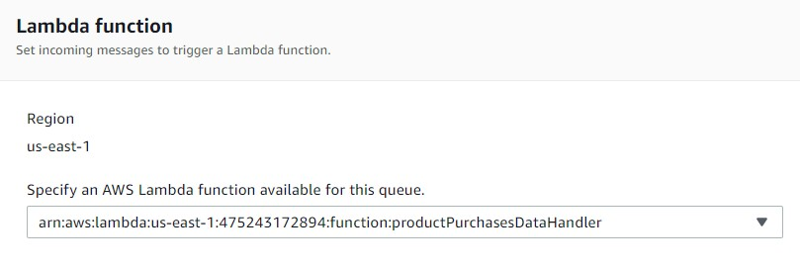

Exercise 4 - Send message via AWS CloudShell to test the SQS Queue
Task 1 – Run the Test Code

We will run AWS CLI commands to test that messages placed in the queue are properly processed by Lambda and added to the DynamoDB table.
- Open AWS CloudShell and upload and extract the zip file download. You can also use the wget command with the S3 download URL.

- Unzip the download and change to the Part-1 folder in which the ‘messagebody-1.json’ file is (build-a-serverless-app\Part-1).

- Modify the queue URL for the command in the instructions.md file. Then run the command.

aws sqs send-message --queue-url **YOUR-QUEUE-URL** -message-body file://message-body-1.json

If this works, we should see Lambda has written items to the DynamoDB Table which will correspond to the JSON file of whichever message-body you have chosen. Feel free to run this command with all 5 message bodies to see them populate the DynamoDB table.

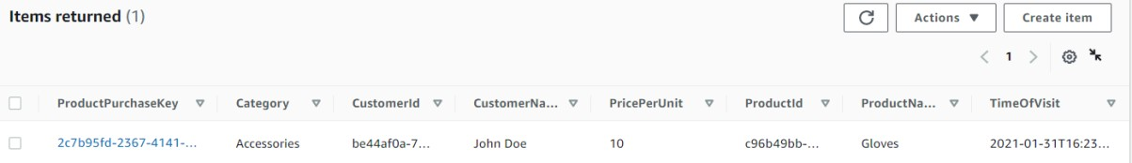

Exercise 5 – Create the second Lambda Function
Task 1 – Create the IAM Role

Next, we will create the second Lambda execution role.
- Head over to the IAM console and click on Create policy.

- Copy the contents of the "lambda-policy.json" file (from the Part-2 folder) into the JSON field, ensuring you replace your account number.

- Click ‘Create Policy after calling the permissions policy ‘productPurchasesSendMessage’.

- We then need to attach this policy to a role. Select Roles in the IAM console and click ‘Create Role’.

- Under ‘Use Case’ select Lambda and click next.

- Filter the permissions policy by typing in the name of the policy we just created (‘productPurchasesSendMessage’) attach it and click next.

- We will then call the role ‘productPurchasesSendMessage’ and click ‘Create Role.
Task 2 – Create the Second Lambda function

We will now create another Lambda function. This function will be receive order information from the frontend API and then place the order information into the queue for subsequent processing.
- Using AWS CloudShell, navigate to the Part-
2/DCTProductPurchaseForm\backend folder and edit the index.js file.

- Update the queue url in the index.js with your SQS queue URL and save the file.

- Zip the files by running “zip -r backend.zip *”.

- Create an AWS Lambda function and call it
‘productPurchasesSendDataToQueue’, select the node.js 16.x runtime.

- Select the ‘productPurchasesSendMessage’ which we created earlier for the Lambda execution role.

- Click ‘Create Function.

- Download the backend.zip and then upload to Lambda. Or use the command in the instructions.md file to copy directly.

Exercise 6 – Create the API
Task 1 – Create the REST API.

We will now create the REST API.
- Head to the API Gateway console, and click Build under the REST API – do not click the Private option, make sure you build this one:

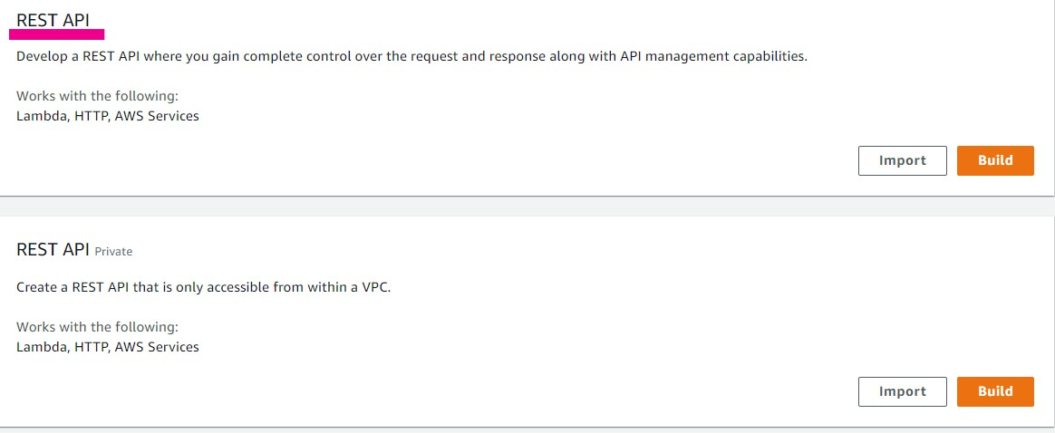
- Select ‘new api’ and call it ‘productPurchase’.
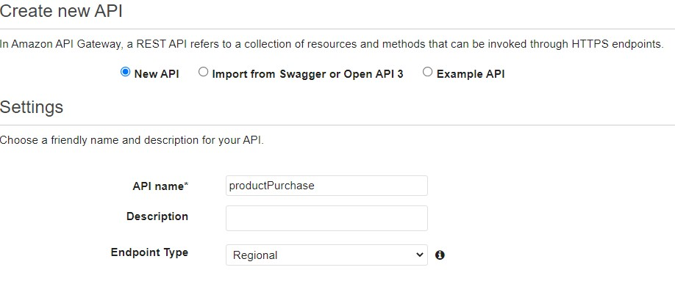

Name the API ‘productPurchase’ and click Create API.

- Under actions click ‘create resource’ and call the resource
‘productpurchase’ and ensure the resource path is /productpurchase.

- Enable Cross origin resource sharing (CORS) and click ‘Create Resource’.

- Under ‘Actions’ click ‘Create Method’ and select ‘PUT’ from the dropdown and click the tick box to create the PUT method.

- Tick the box to enable this is a Lambda Proxy integration and select the ‘productPurchasesSendDataToQueue’ for the Lambda function.
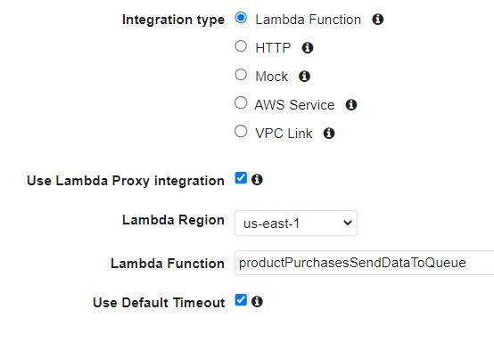

Click save and click OK.

- Under Actions click ‘Deploy API’ – and choose ‘new stage’ and call the stage ‘dev’. Click Deploy.

- Under ‘SDK Generation’ select the ‘JavaScript’ platform and click
‘Generate SDK’.

- Upload the zip file to CloudShell.

- Run the commands in the instructions.md file to copy the SDK files to the frontend directory.

Exercise 7 - Create the Static Website and test the application
Task 1 – Create the S3 Bucket.

We will now create the S3 bucket which will host the code for the static website.
- Head over to the S3 console and click ‘Create Bucket’.

- Call the bucket ‘product-purchases-webform-XXXX with the Xs numbers representing a random string of letters or numbers, so it remains globally unique.

- Disable and acknowledge blocking all public access and click ‘Create Bucket’.

- Once the bucket is created, go to the properties tab, and enable static website hosting, and type ‘index.html’ for the index document.

- Go to the Permissions section and add the permissions statements from the ‘frontend-bucket-policy.json’ file. Make sure to change the name of the bucket and save changes.

- We will next upload the frontend code using CloudShell.

- Using your terminal/command prompt, navigate to the
‘DCTProductPurchaseForm’ directory.

- From the frontend directory, run the command, to copy the files to S3 (with your bucket name specified).

aws s3 sync ./ s3://product-purchases-webform-

- You should see a series of commands running which show all the frontend contents being uploaded.

- If we check the S3 bucket – there should be the code for the website!

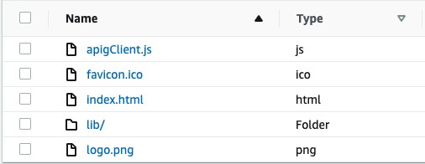

- Click on the index.html document and copy the object URL and paste it into the browser.

- Alternatively, you can use the static website endpoint (HTTP only).

The following website should load:

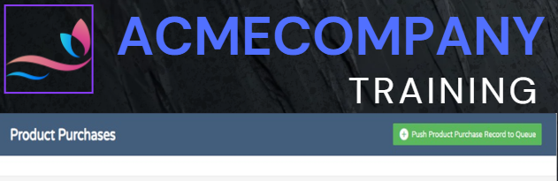

- Click ‘push product visit record to queue’ and enter some information, like this, and click ‘Add’.

- It should have appeared in the DynamoDB table!

